Market Trends | Competitor Performance - 2021

P&C Reinsurance
Continued investment required despite (necessary) circumspection
Underwriting margins have lifted (largely) due to insurer actions in recent years, but questions of margin sufficiency remain in an industry generally dissatisfied with its long-term performance.
Concerns about existing portfolio profitability remain elevated for insurers, unsure as to how Covid-19 exposures will ultimately resolve, even though current claims developments have proved favourable relative to provisions. ‘Social inflation’, coupled with signs of rising economic inflation globally, mean that these will likely remain elevated.
The rising pressures of meeting growth expectations is a strong signal from the 2021 feedback, as insurers and reinsurance brokers wrestle with a pandemic that is significantly protracted relative to expectations.
Exhibit 1 – Timeframe to expected commercial recovery from Covid-19
Insurer and reinsurance broker expectations on the time to recovery (months). Feedback: Feb to May 2021. Global expectations of recovery by Q3 2022.
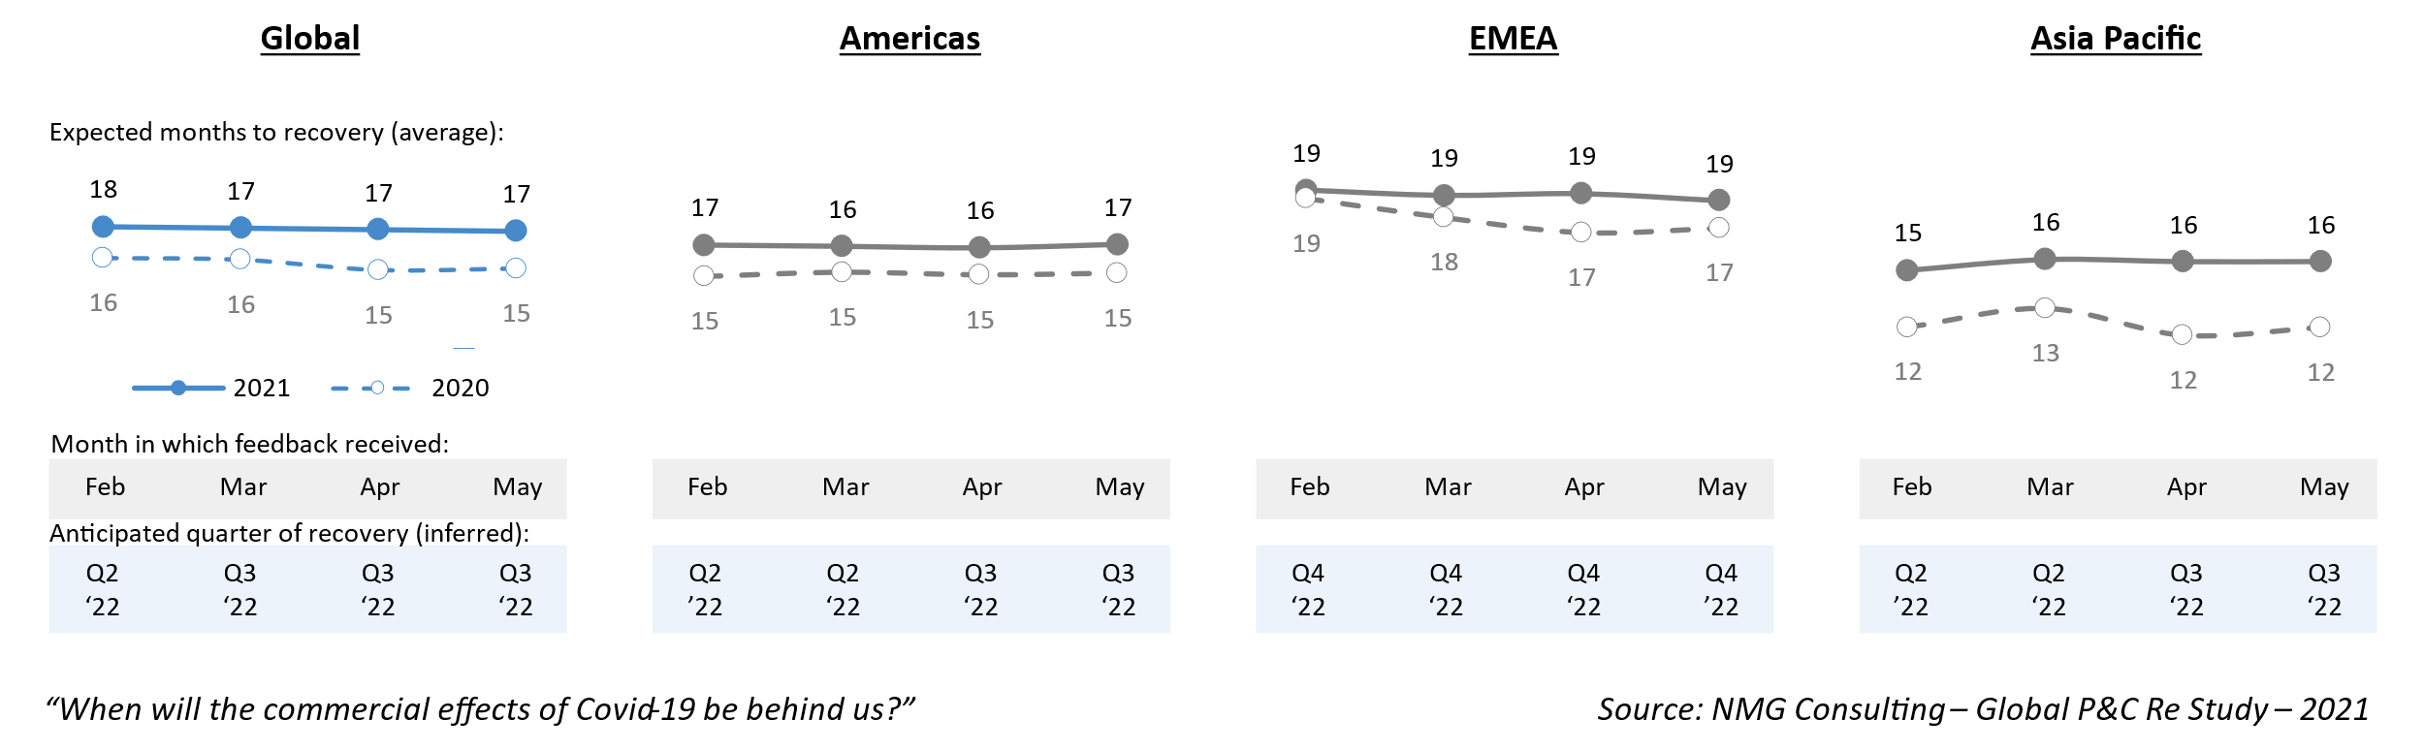
Digitalisation investments continue to drive a re-organisation of the insurance value chain, being notably both complex and extended the general insurance industry. Insurtech investment continues to escalate. As a survival imperative, insurers are faced with investing in new platforms for data management and automation, as well as becoming fully digitally-enabled.
Viable strategies for sustainably higher margins are needed to merit the required investments to modernise. Late adopters will certainly find this more difficult.
In contrast to commercial concerns, risk-related concerns generally receded (‘external environment’, ‘emerging risks’ & ‘claims’ concerns fell) from the highest levels set in 2021.
[Feel like we need to present digital etc more clearly in the chart below. Options include to extend or group.]

Exhibit 2 – Leading challenges
Proportion of executives indicating as a leading challenge. Maximum of 3. Feb-May 2021
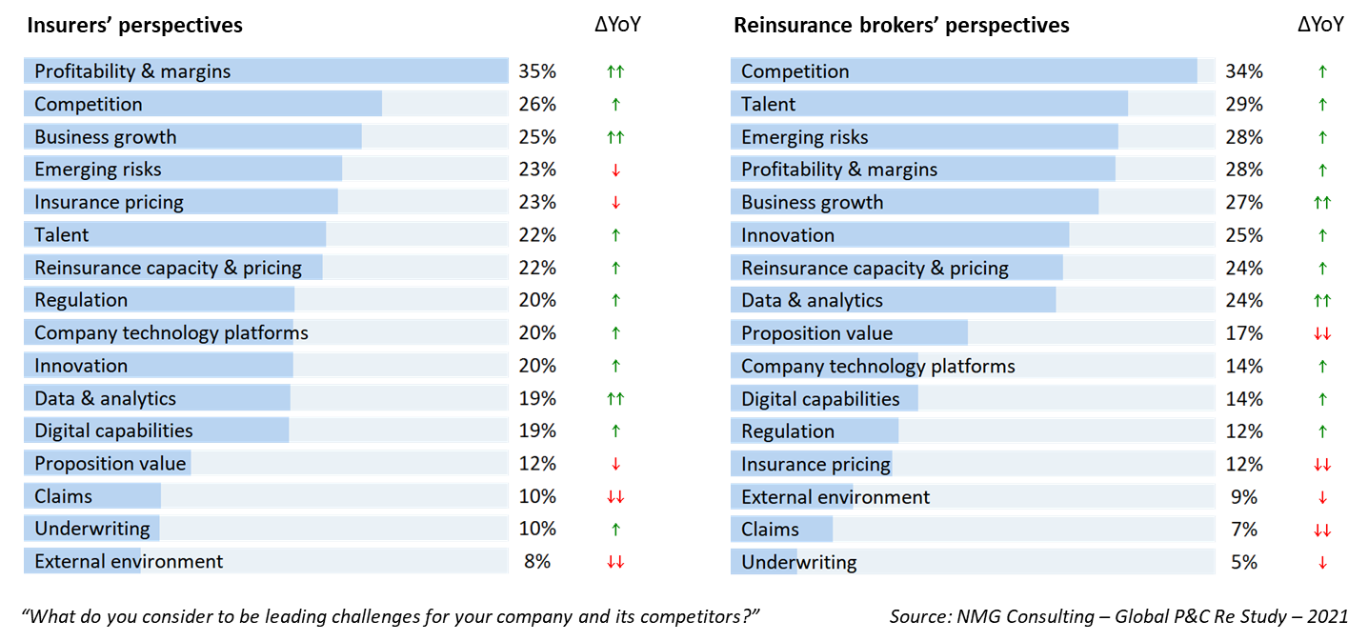

Increased reinsurance prices have yet to peak
Rises in reinsurance rates were widely reported at renewals throughout 2021, building further on rate increases achieved since 2017. [See NMG’s Reinsurance Pricing Report 2021 for a more detailed analysis of price movements: <add NMG Connect link>]
The levels of capital supporting the reinsurance industry have remained largely stable, but low return on equity is both a typical and persistent feature of the industry. Reinsurers have thus continued to be more selective in terms the deployment of capital, particularly given the uncertainties arising from the Covid-19 pandemic.
Historically low fixed-interest yields have also supported a focus on technical underwriting margins, without doubt a positive for the industry overall.
Reinsurers entered the 1/1/2022 renewal with firm expectations for further rate rises, which were consistent with insurer and broker expectations in the first half of 2021.
Exhibit 3 – Insurers correctly anticipated further reinsurance rate increases
A large majority of insurer respondents anticipated increases at renewal (vertical axis), although views as to the adequacy of reinsurance rates were more divided (horizontal axis)
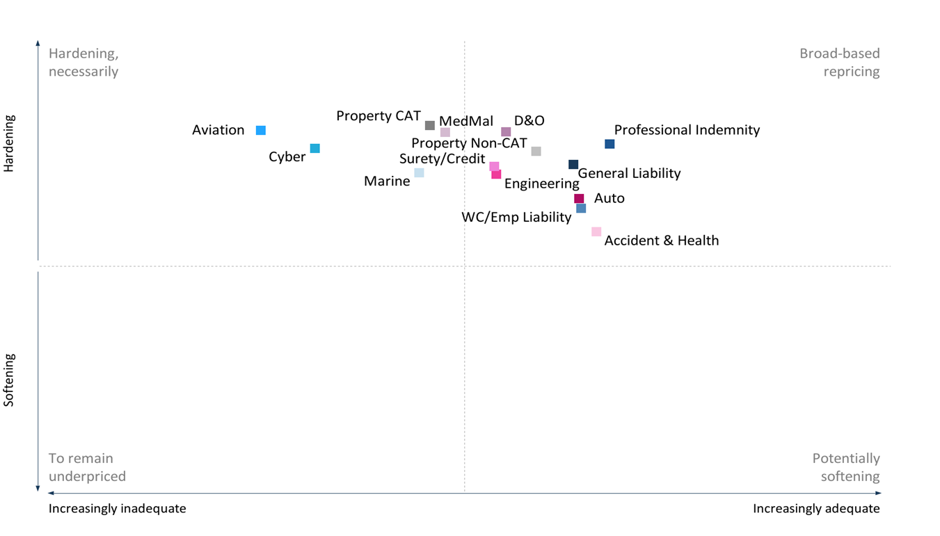
Source: NMG Consulting – P&C Reinsurance Study – 2021
Broadly (just) one-half of insurers and reinsurance brokers still view current prices to be adequate. Views shared about price ‘inadequacy’ moderated towards ‘uncertainty’ with only 12% of respondents (vs 21% in 2020) viewing current reinsurance pricing as inadequate – of which insurers and reinsurance brokers held a common view that prices for Aviation and Cyber risks remain most under-priced.
This moderation notwithstanding, insurers and reinsurance brokers expect further price hardening across all regions and lines of business into 2022.
The views of insurers and reinsurance brokers typically differ more around rate adequacy, with insurers less easily swayed by rationales advanced for rate increases based on adequacy.

Insurance demonstrates counter-cyclicality
Despite the Covid-19 pandemic, growth expectations increased by 1.8% from 2020. With expectations for growth across both commercial and personal lines. While higher insurance premiums were a key growth driver globally, growth in developing markets was largely driven by new customer growth, benefiting in part from an increase in risk awareness.

One of the 2021 innovations was to get Commercials Lines growth expectations separately from Personal Lines. Let’s take a look at that and see if it would add further to the chart below.
Exhibit 4: GWP growth expectations lifting to pre-pandemic levels
~2000 views of executives and practitioners at insurers in 2021, providing a 12-month view of growth their company in their country(ies)
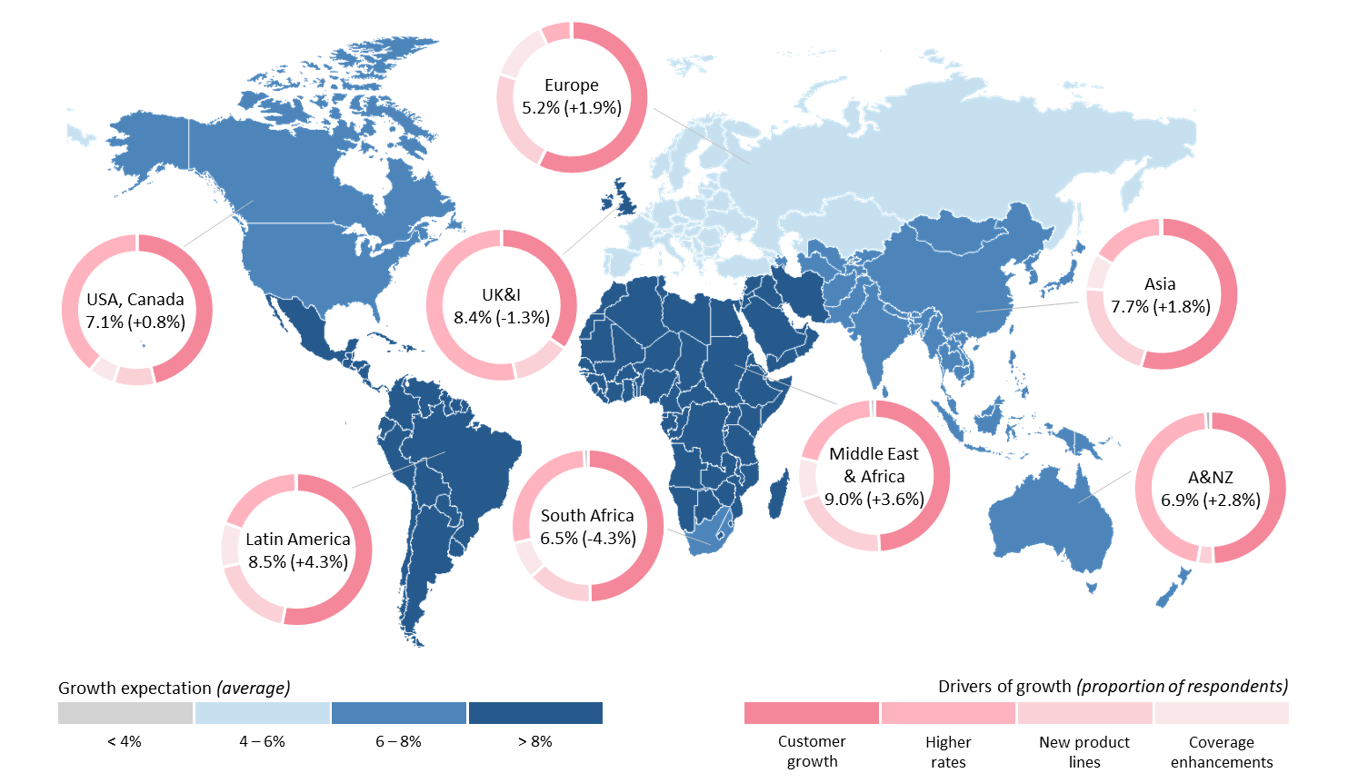
Source: NMG Consulting – P&C Reinsurance Study – 2021

The wisdom of the crowd: The views of a broad sample of individuals is a better statistical predictor than those of a single expert, although statistically it would seem in our analyses that people find it harder anticipate business shrinkage at the company level.

Brand matters
Brand confers competitive benefit in reinsurance.
‘Best-quality’ reinsurer brands clearly correlate (positively) with scale and competitive position, but vary significantly between reinsurers with similar levels of market importance.
Reinsurer brands can be categorised between Global, Regional, and Local. Eight brands emerge from the analysis as being genuinely Global, carrying their value statement across all regions.
Exhibit 5: Top 50 brands – Property, Casualty & Speciality Reinsurance
Rankings derived by way of a synthetic index from the unprompted views of insurers and reinsurance brokers as to the “best-quality brands”, partner preferences including those by line of business (> 30,000 datapoints)
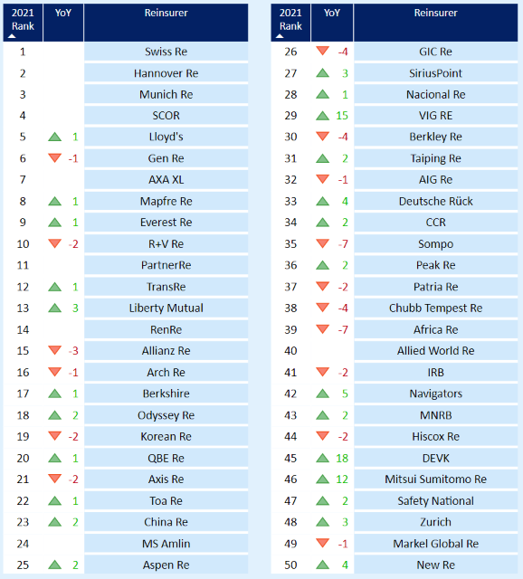
Source: NMG Consulting – P&C Reinsurance Study – 2021

Competitive positioning – Reinsurers
Swiss Re again received the highest ratings from insurers on NMG’s Business Capability Index (ahead of Hannover Re and Munich Re). From reinsurance brokers, Hannover Re received the highest ratings for the first time (ahead of Swiss Re).
In a challenging year, ratings for the 20 most-used reinsurers held steady from insurers while lifting slightly (+0.8) on average with reinsurance brokers. In particular, insurers awarded higher ratings to reinsurers for innovation while ratings held steady in key areas such as underwriting and ‘getting deals done’, despite firmer prices and terms.
Exhibit 6: Business Capability Index – Global
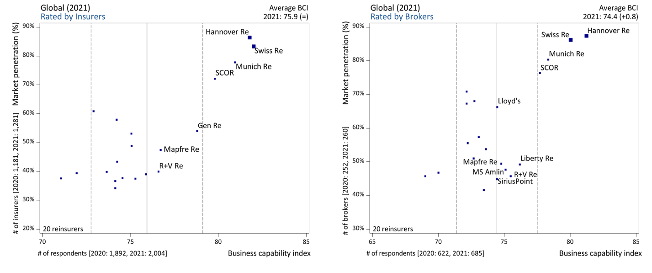
Market penetration indicates the proportion of insurers where reinsurers are active, while NMG’s BCI aggregates ratings awarded across a range of performance factors for reinsurers and is thus a predictive indicator of future trading success

Source: NMG Consulting – P&C Reinsurance Study – 2021
Exhibit 7: Reinsurer performance
Average ratings of the 15 most-used reinsurers globally as evaluated by insurers and reinsurance brokers
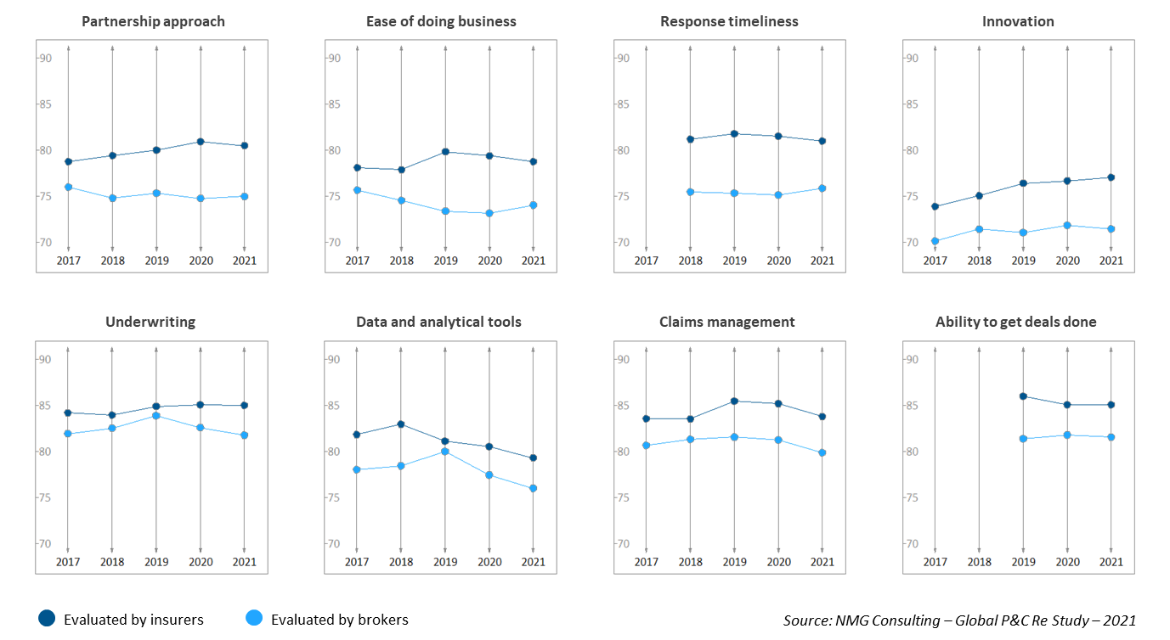

Not a commodity
In addition to specialisation within lines of business, our analysis of competitive performance reveals a rich topography of points of competitive differentiation at the customer interface with insurers, reinsurance brokers and across regions.
This is a positive signal for an industry often considered transactional and commoditised, but also suggests that one-half of the potential universe of differentiation opportunities current lies unclaimed.
Exhibit 8: Lead reinsurers by factor (Treaty business)
Insurers and reinsurance brokers look for different capabilities when engaging reinsurance partners in leading and following roles, while reinsurers perform differentially across factors and roles
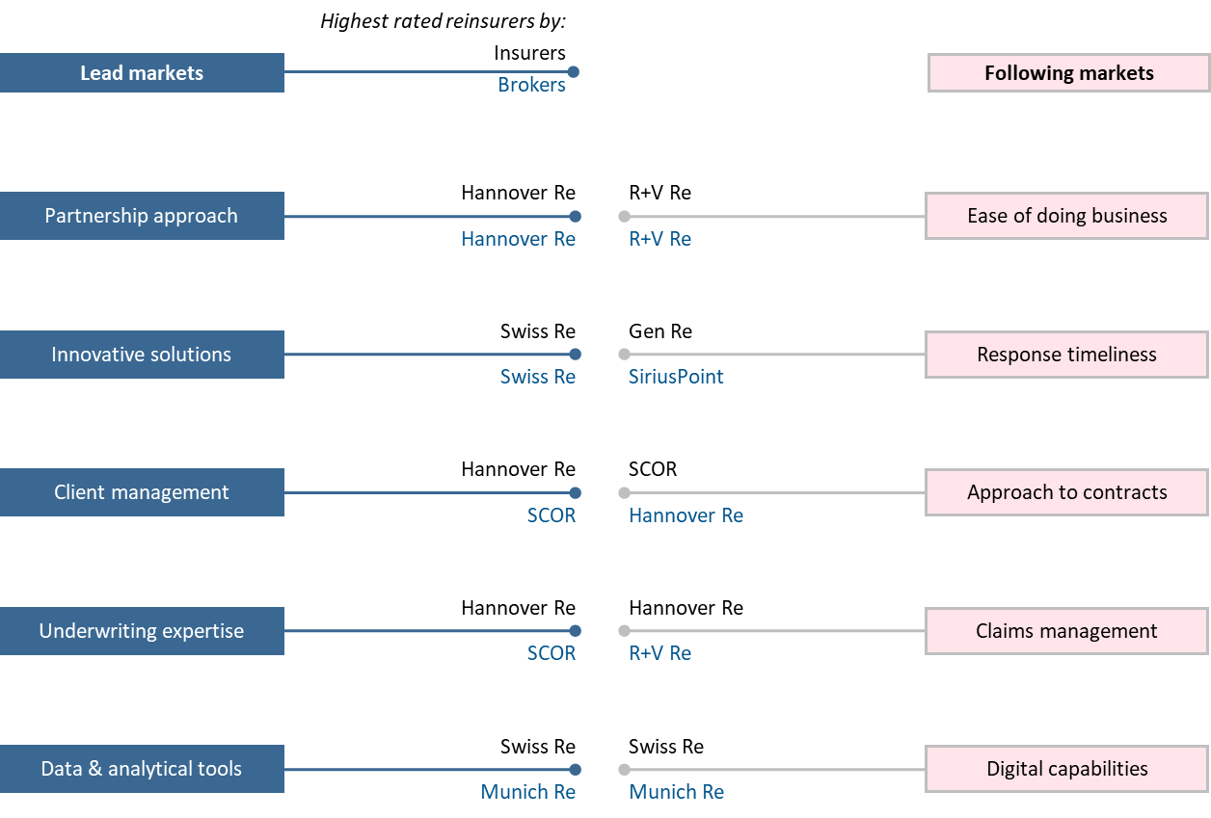
Source: NMG Consulting – P&C Reinsurance Study – 2021

Mark Prichard is the CEO of NMG Consulting based in Sydney (Mark.Prichard@NMG-Group.com)
Jane Cheng, Partner based in Sydney (Jane.Cheng@NMG-Group.com)
Rick Flaspohler, Partner based in Kansas City (Rick.Flaspohler@NMG-Group.com)
Desiree Lim, Consultant based in Singapore (Desiree.Lim@NMG-Group.com)

